Exercise 1:

Run the code provided in the website and use it for the optimization of function provided in this

## manual and the ones used in previous lab.

## Code

import numpy as np

import matplotlib.pyplot as plt

from matplotlib.animation import FuncAnimation

def f(*x*,*y*):

    "Objective function"

    return (*x*-3.14)**2 + (*y*-2.72)**2 + np.sin(3\**x*+1.41) + np.sin(4\**y*-1.73)

*# Compute and plot the function in 3D within [0,5]x[0,5]*

x, y = np.array(np.meshgrid(np.linspace(0,5,100), np.linspace(0,5,100)))

z = f(x, y)

*# Find the global minimum*

x_min = x.ravel()[z.argmin()]

y_min = y.ravel()[z.argmin()]

*# Hyper-parameter of the algorithm*

c1 = c2 = 0.1

w = 0.8

*# Create particles*

n_particles = 20

np.random.seed(100)

X = np.random.rand(2, n_particles) * 5

V = np.random.randn(2, n_particles) * 0.1

*# Initialize data*

pbest = X

pbest_obj = f(X[0], X[1])

gbest = pbest[:, pbest_obj.argmin()]

gbest_obj = pbest_obj.min()

def update():

    "Function to do one iteration of particle swarm optimization"

    global V, X, pbest, pbest_obj, gbest, gbest_obj

*# Update params*

    r1, r2 = np.random.rand(2)

    V = w * V + c1*r1*(pbest - X) + c2*r2*(gbest.reshape(-1,1)-X)

    X = X + V

    obj = f(X[0], X[1])

    pbest[:, (pbest_obj >= obj)] = X[:, (pbest_obj >= obj)]

    pbest_obj = np.array([pbest_obj, obj]).min(*axis*=0)

    gbest = pbest[:, pbest_obj.argmin()]

    gbest_obj = pbest_obj.min()

*# Set up base figure: The contour map*

fig, ax = plt.subplots(*figsize*=(8,6))

fig.set_tight_layout(True)

img = ax.imshow(z, *extent*=[0, 5, 0, 5], *origin*='lower', *cmap*='viridis', *alpha*=0.5)

fig.colorbar(img, *ax*=ax)

ax.plot([x_min], [y_min], *marker*='x', *markersize*=5, *color*="white")

contours = ax.contour(x, y, z, 10, *colors*='black', *alpha*=0.4)

ax.clabel(contours, *inline*=True, *fontsize*=8, *fmt*="%.0f")

pbest_plot = ax.scatter(pbest[0], pbest[1], *marker*='o', *color*='black', *alpha*=0.5)

p_plot = ax.scatter(X[0], X[1], *marker*='o', *color*='blue', *alpha*=0.5)

p_arrow = ax.quiver(X[0], X[1], V[0], V[1], *color*='blue', *width*=0.005, *angles*='xy', *scale_units*='xy', *scale*=1)

gbest_plot = plt.scatter([gbest[0]], [gbest[1]], *marker*='*', *s*=100, *color*='black', *alpha*=0.4)

ax.set_xlim([0,5])

ax.set_ylim([0,5])

def animate(*i*):

    "Steps of PSO: algorithm update and show in plot"

    title = 'Iteration {:02d}'.format(*i*)

*# Update params*

    update()

*# Set picture*

    ax.set_title(title)

    pbest_plot.set_offsets(pbest.T)

    p_plot.set_offsets(X.T)

    p_arrow.set_offsets(X.T)

    p_arrow.set_UVC(V[0], V[1])

    gbest_plot.set_offsets(gbest.reshape(1,-1))

    return ax, pbest_plot, p_plot, p_arrow, gbest_plot

anim = FuncAnimation(fig, animate, *frames*=list(range(1,50)), *interval*=500, *blit*=False, *repeat*=True)

anim.save("task1.gif", *dpi*=120, *writer*="imagemagick")

print("PSO found best solution at f({})={}".format(gbest, gbest_obj))

print("Global optimal at f({})={}".format([x_min,y_min], f(x_min,y_min)))

## Output



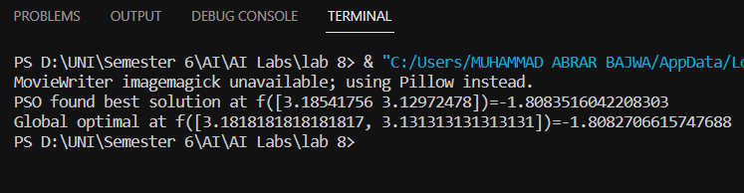

# Exercise 1 Lab 8 Functions

## Code

*# Exercise 1*

*# Lab 8 Functions*

import numpy as np

import matplotlib.pyplot as plt

import matplotlib.animation as animation

def f(*x*, *y*):

    return (*x* - 3.14) ** 2 + (*y* - 2.72) ** 2 + np.sin(3 * *x* + 1.41) + np.sin(4 * *y* - 1.73)

def pso_animation():

    search_min = -10

    search_max = 10

    num_dims = 2

    swarm_size = 50

    max_iter = 100

    c1 = 2.0

    c2 = 2.0

    w = 0.7

    swarm_pos = np.random.uniform(search_min, search_max, (swarm_size, num_dims))

    swarm_vel = np.zeros((swarm_size, num_dims))

    swarm_best_pos = np.copy(swarm_pos)

    swarm_best_fitness = np.full((swarm_size,), np.inf)

    global_best_pos = np.zeros((num_dims,))

    global_best_fitness = np.inf

    fig, ax = plt.subplots()

    x = np.linspace(search_min, search_max, 100)

    y = np.linspace(search_min, search_max, 100)

    X, Y = np.meshgrid(x, y)

    Z = f(X, Y)

    ax.contour(X, Y, Z, *levels*=50, *cmap*='jet')

    ax.set_xlim([search_min, search_max])

    ax.set_ylim([search_min, search_max])

    sc = ax.scatter([], [])

    def animate(*i*):

        nonlocal swarm_pos, swarm_vel, swarm_best_pos, swarm_best_fitness, global_best_pos, global_best_fitness

        fitness = f(swarm_pos[:, 0], swarm_pos[:, 1])

        better_fitness_mask = fitness < swarm_best_fitness

        swarm_best_pos[better_fitness_mask] = swarm_pos[better_fitness_mask]

        swarm_best_fitness[better_fitness_mask] = fitness[better_fitness_mask]

        best_particle_idx = np.argmin(swarm_best_fitness)

        if swarm_best_fitness[best_particle_idx] < global_best_fitness:

            global_best_pos = np.copy(swarm_best_pos[best_particle_idx])

            global_best_fitness = swarm_best_fitness[best_particle_idx]

        r1 = np.random.uniform(*size*=(swarm_size, num_dims))

        r2 = np.random.uniform(*size*=(swarm_size, num_dims))

        swarm_vel = w * swarm_vel + c1 * r1 * (swarm_best_pos - swarm_pos) + c2 * r2 * (global_best_pos - swarm_pos)

        swarm_pos += swarm_vel

        swarm_pos = np.clip(swarm_pos, search_min, search_max)

        sc.set_offsets(swarm_pos)

        return sc,

    ani = animation.FuncAnimation(fig, animate, *frames*=max_iter, *interval*=50, *blit*=True)

    ani.save("Task1_2.gif", *dpi*=120, *writer*="imagemagick")

    plt.show()

pso_animation()

## Output



# Exercise 1 Lab 7 Functions

## Code

*# Exercise 1*

*# Lab 7 Functions*

import numpy as np

import matplotlib.pyplot as plt

from matplotlib.animation import FuncAnimation

def f(*x*, *y*):

    return (1 - *x*) ** 2 + 100 * (*y* - *x* ** 2) ** 2

def pso(*fitness_func*, *swarm_size*=50, *max_iter*=100, *c1*=2.0, *c2*=2.0, *w*=0.7):

    search_min = -5

    search_max = 5

    num_dims = 2

    swarm_pos = np.random.uniform(search_min, search_max, (*swarm_size*, num_dims))

    swarm_vel = np.zeros((*swarm_size*, num_dims))

    swarm_best_pos = np.copy(swarm_pos)

    swarm_best_fitness = np.full((*swarm_size*,), np.inf)

    global_best_pos = np.zeros((num_dims,))

    global_best_fitness = np.inf

    positions_history = []  *# for animation*

    for i in range(*max_iter*):

        fitness = *fitness_func*(swarm_pos[:, 0], swarm_pos[:, 1])

        better_fitness_mask = fitness < swarm_best_fitness

        swarm_best_pos[better_fitness_mask] = swarm_pos[better_fitness_mask]

        swarm_best_fitness[better_fitness_mask] = fitness[better_fitness_mask]

        best_particle_idx = np.argmin(swarm_best_fitness)

        if swarm_best_fitness[best_particle_idx] < global_best_fitness:

            global_best_pos = np.copy(swarm_best_pos[best_particle_idx])

            global_best_fitness = swarm_best_fitness[best_particle_idx]

        r1 = np.random.uniform(*size*=(*swarm_size*, num_dims))

        r2 = np.random.uniform(*size*=(*swarm_size*, num_dims))

        swarm_vel = *w* * swarm_vel + *c1* * r1 * (swarm_best_pos - swarm_pos) + *c2* * r2 * (global_best_pos - swarm_pos)

        swarm_pos += swarm_vel

        swarm_pos = np.clip(swarm_pos, search_min, search_max)

        positions_history.append(np.copy(swarm_pos))  *# for animation*

    return global_best_pos, global_best_fitness, positions_history

best_pos, best_fitness, positions_history = pso(f)

fig, ax = plt.subplots()

scat = ax.scatter([], [])

def init():

    ax.set_xlim(-5, 5)

    ax.set_ylim(-5, 5)

    return scat,

def update(*i*):

    scat.set_offsets(positions_history[*i*])

    return scat,

ani = FuncAnimation(fig, update, *frames*=len(positions_history), *init_func*=init, *blit*=True)

ani.save("task1_3.gif", *dpi*=120, *writer*="imagemagick")

plt.show()

## Output



Exercise 2

Use matplotlib to plot the objective functions and creating an animation showing the convergence

process. Like the one shown in the site

[Swarm Intelligence: Coding and Visualising Particle Swarm Optimisation in Python | by Ken Moriwaki | Towards Data Science](https://towardsdatascience.com/swarm-intelligence-coding-and-visualising-particle-swarm-optimisation-in-python-253e1bd00772)

# Code from Website

import random

import numpy as np

from matplotlib import pyplot as plt

from matplotlib import animation

def fitness_function(*x1*, *x2*):

    f1 = *x1* + 2 * -*x2* + 3

    f2 = 2 * *x1* + *x2* - 8

    z = f1 ** 2 + f2 ** 2

    return z

def update_velocity(*particle*, *velocity*, *pbest*, *gbest*, *w_min*=0.5, *max*=1.0, *c*=0.1):

    num_particle = len(*particle*)

    new_velocity = np.array([0.0 for i in range(num_particle)])

    r1 = random.uniform(0, *max*)

    r2 = random.uniform(0, *max*)

    w = random.uniform(*w_min*, *max*)

    c1 = *c*

    c2 = *c*

    for i in range(num_particle):

        new_velocity[i] = w * *velocity*[i] + c1 * r1 * (*pbest*[i] - *particle*[i]) + c2 * r2 * (*gbest*[i] - *particle*[i])

    return new_velocity

def update_position(*particle*, *velocity*):

    new_particle = *particle* + *velocity*

    return new_particle

def pso_2d(*population*, *dimension*, *position_min*, *position_max*, *generation*, *fitness_criterion*):

    particles = [[random.uniform(*position_min*, *position_max*) for j in range(*dimension*)] for i in range(*population*)]

    pbest_position = particles

    pbest_fitness = [fitness_function(p[0], p[1]) for p in particles]

    gbest_index = np.argmin(pbest_fitness)

    gbest_position = pbest_position[gbest_index]

    velocity = [[0.0 for j in range(*dimension*)] for i in range(*population*)]

    for t in range(*generation*):

        if np.average(pbest_fitness) <= *fitness_criterion*:

            break

        else:

            for n in range(*population*):

                velocity[n] = update_velocity(particles[n], velocity[n], pbest_position[n], gbest_position)

                particles[n] = update_position(particles[n], velocity[n])

        pbest_fitness = [fitness_function(p[0], p[1]) for p in particles]

        pbest_position = [particles[i] if pbest_fitness[i] < fitness_function(pbest_position[i][0], pbest_position[i][1]) else pbest_position[i] for i in range(*population*)]

        gbest_index = np.argmin(pbest_fitness)

        gbest_position = pbest_position[gbest_index]

    print('Global Best Position: ', gbest_position)

    print('Best Fitness Value: ', min(pbest_fitness))

    print('Average Particle Best Fitness Value: ', np.average(pbest_fitness))

    print('Number of Generation: ', t)

    return particles, pbest_position, pbest_fitness

population = 100

dimension = 2

position_min = -100.0

position_max = 100.0

generation = 400

fitness_criterion = 10e-4

particles = [[random.uniform(position_min, position_max) for j in range(dimension)] for i in range(population)]

pbest_position = particles

pbest_fitness = [fitness_function(p[0],p[1]) for p in particles]

gbest_index = np.argmin(pbest_fitness)

gbest_position = pbest_position[gbest_index]

velocity = [[0.0 for j in range(dimension)] for i in range(population)]

fig = plt.figure(*figsize*=(10, 10))

ax = fig.add_subplot(111, *projection*='3d')

ax.set_xlabel('x')

ax.set_ylabel('y')

ax.set_zlabel('z')

x = np.linspace(position_min, position_max, 80)

y = np.linspace(position_min, position_max, 80)

X, Y = np.meshgrid(x, y)

Z= fitness_function(X,Y)

ax.plot_wireframe(X, Y, Z, *color*='r', *linewidth*=0.2)

images = []

for t in range(generation):

    if np.average(pbest_fitness) <= fitness_criterion:

        break

    else:

        for n in range(population):

            velocity[n] = update_velocity(particles[n], velocity[n], pbest_position[n], gbest_position)

            particles[n] = update_position(particles[n], velocity[n])

        pbest_fitness = [fitness_function(p[0],p[1]) for p in particles]

        for i in range(population):

            if pbest_fitness[i] < fitness_function(pbest_position[i][0], pbest_position[i][1]):

                pbest_position[i] = particles[i]

        gbest_index = np.argmin(pbest_fitness)

        gbest_position = pbest_position[gbest_index]

    image = ax.scatter3D([particles[n][0] for n in range(population)],

                        [particles[n][1] for n in range(population)],

                        [fitness_function(particles[n][0],particles[n][1]) for n in range(population)], *c*='b')

    images.append([image])

animated_image = animation.ArtistAnimation(fig, images)

animated_image.save('./task2.gif', *writer*='pillow')

print('Global Best Position: ', gbest_position)

print('Best Fitness Value: ', min(pbest_fitness))

print('Average Particle Best Fitness Value: ', np.average(pbest_fitness))

print('Number of Generation: ', t+1)

## Output



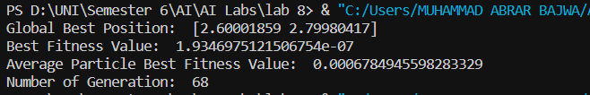

# Exercise 2 Using matplotlib to plot the objective functions and creating an animation showing the convergence process.

## Code

import numpy as np

import matplotlib.pyplot as plt

from matplotlib.animation import FuncAnimation

def objective(*x*, *y*):

    return (*x* - 3.14) ** 2 + (*y* - 2.72) ** 2 + np.sin(3 * *x* + 1.41) + np.sin(4 * *y* - 1.73)

x_range = np.linspace(-5, 5, 100)

y_range = np.linspace(-5, 5, 100)

X, Y = np.meshgrid(x_range, y_range)

Z = objective(X, Y)

fig, ax = plt.subplots()

ax.contourf(X, Y, Z, *levels*=50, *cmap*='jet')

ax.set_xlabel('x')

ax.set_ylabel('y')

ax.set_title('Objective Function')

def optimize(*learning_rate*, *num_iterations*):

    x = np.random.uniform(-5, 5)

    y = np.random.uniform(-5, 5)

    history = []

    for i in range(*num_iterations*):

        gradient_x = 2 * (x - 3.14) + 3 * np.cos(3 * x + 1.41)

        gradient_y = 2 * (y - 2.72) + 4 * np.cos(4 * y - 1.73)

        x -= *learning_rate* * gradient_x

        y -= *learning_rate* * gradient_y

        history.append((x, y))

    return (x, y), history

def animate(*frame*):

    learning_rate = 0.1

    num_iterations = *frame* + 1

    (x, y), history = optimize(learning_rate, num_iterations)

    path = np.array(history)

    ax.plot(path[:, 0], path[:, 1], *color*='black', *alpha*=0.1)

    ax.plot(x, y, 'o', *color*='black')

    ax.set_title(f'Optimization (Learning Rate = {learning_rate}, Iterations = {num_iterations})')

ani = FuncAnimation(fig, animate, *frames*=100, *interval*=100)

ani.save('./task2_1.gif', *writer*='pillow')

plt.show()

## Output



Exercise 3

Use your code to find the optimal solutions of all the optimization functions in the class lecture of

week 4.

# Exercise 3 from Week 4 Lecture

## Trajectory (S-metaheuristics) Algorithm 1

## Code

*# Trajectory (S-metaheuristics)*

import random

import numpy as np

import matplotlib.pyplot as plt

from matplotlib.animation import FuncAnimation

def objective_function(*x*):

    return *x* ** 2

def generate_candidates(*current_solution*):

    candidates = []

    for _ in range(10):

        candidate = random.uniform(-10, 10)

        candidates.append(candidate)

    return candidates

def select_candidate(*candidates*):

    selected_candidate = min(*candidates*, *key*=objective_function)

    return selected_candidate

def s_metaheuristic(*initial_solution*, *stopping_criteria*):

    current_solution = *initial_solution*

    iteration = 0

    while True:

        candidates = generate_candidates(current_solution)

        selected_candidate = select_candidate(candidates)

        current_solution = selected_candidate

        iteration += 1

*stopping_criteria* = True

        if *stopping_criteria*:

            break

    best_solution = current_solution

    return best_solution

def update_plot(*solution*):

    plt.cla()

    x = np.linspace(-10, 10, 100)

    y = objective_function(x)

    plt.plot(x, y, 'b-', *label*='Objective Function')

    plt.scatter(*solution*, objective_function(*solution*), *c*='r', *label*='Current Solution')

    plt.xlim(-10, 10)

    plt.ylim(0, 100)

    plt.xlabel('x')

    plt.ylabel('f(x)')

    plt.legend()

initial_solution = 0

stopping_criteria = False

fig, ax = plt.subplots()

def animate(*frame*):

    best_solution = s_metaheuristic(initial_solution, stopping_criteria)

    update_plot(best_solution)

    if stopping_criteria:

        anim.event_source.stop()

anim = FuncAnimation(fig, animate, *frames*=range(1), *repeat*=False)

anim.save('./task3.gif', *writer*='pillow')

plt.show()

## Output

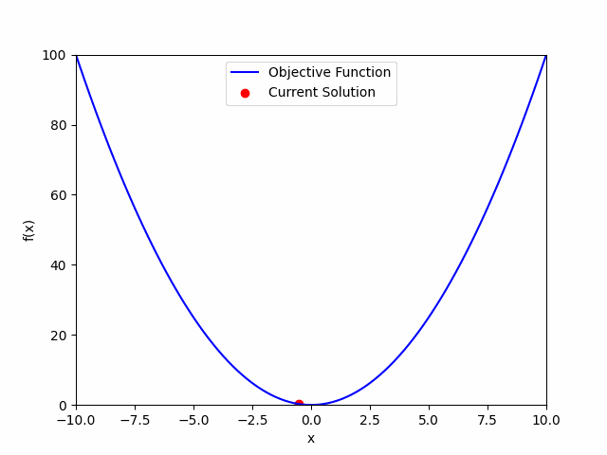

## A Population-based metaheuristics (P-metaheuristics) Algorithm 2

## Code

*#  a population-based metaheuristic (P-metaheuristic) algorithm*

import random

import numpy as np

import matplotlib.pyplot as plt

from matplotlib.animation import FuncAnimation

def objective_function(*x*):

    return *x* ** 2

def generate_population(*population_size*):

    population = []

    for _ in range(*population_size*):

        solution = random.uniform(-10, 10)  *# Example: Generate random solutions within range [-10, 10]*

        population.append(solution)

    return population

def replace_population(*population*):

*# Generate a new population based on the current population*

    new_population = *population*.copy()

    return new_population

def preselect_population(*population*):

    new_population = *population*.copy()

    return new_population

def p_metaheuristic(*population_size*, *stopping_criteria*):

    population = generate_population(*population_size*)

    iteration = 0

    while True:

        population = replace_population(population)

        population = preselect_population(population)

        iteration += 1

*stopping_criteria* = True

        if *stopping_criteria*:

            break

    best_solution = min(population, *key*=objective_function)

    return best_solution

def update_plot(*solution*):

    plt.cla()

    x = np.linspace(-10, 10, 100)

    y = objective_function(x)

    plt.plot(x, y, 'b-', *label*='Objective Function')

    plt.scatter(*solution*, objective_function(*solution*), *c*='r', *label*='Current Solution')

    plt.xlim(-10, 10)

    plt.ylim(0, 100)

    plt.xlabel('x')

    plt.ylabel('f(x)')

    plt.legend()

population_size = 10

stopping_criteria = False

fig, ax = plt.subplots()

def animate(*frame*):

    best_solution = p_metaheuristic(population_size, stopping_criteria)

    update_plot(best_solution)

    if stopping_criteria:

        anim.event_source.stop()

anim = FuncAnimation(fig, animate, *frames*=range(1), *repeat*=False)

anim.save('./task3_1.gif', *writer*='pillow')

plt.show()

## Output

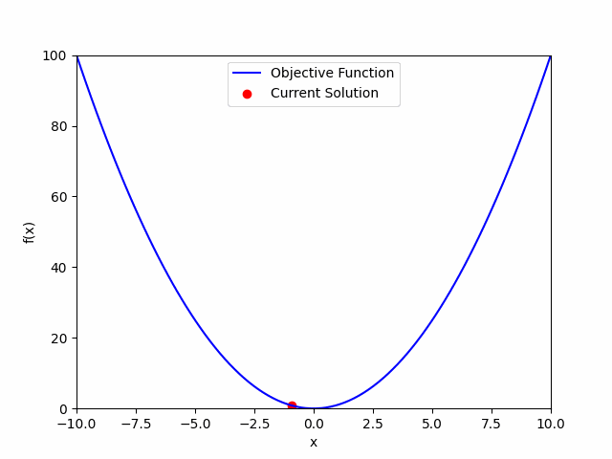

## A Single-based metaheuristics (S-metaheuristics) Algorithm 3

## Code

*# a single-based metaheuristic (S-metaheuristic)*

import random

import numpy as np

import matplotlib.pyplot as plt

from matplotlib.animation import FuncAnimation

def objective_function(*x*):

    return *x* ** 2

def generate_candidates(*current_solutions*):

    candidates = []

    for solution in *current_solutions*:

        for _ in range(10):  *# Generate 10 candidate solutions for each current solution*

            candidate = random.uniform(-10, 10)  *# Example: Generate random candidates within range [-10, 10]*

            candidates.append(candidate)

    return candidates

def select_solution(*candidates*):

    selected_solution = min(*candidates*, *key*=objective_function)

    return selected_solution

def s_metaheuristic(*initial_solutions*, *stopping_criteria*):

    current_solutions = *initial_solutions*.copy()

    iteration = 0

    while True:

        candidates = generate_candidates(current_solutions)

        selected_solution = select_solution(candidates)

        current_solutions = [selected_solution] * len(current_solutions)

        iteration += 1

*stopping_criteria* = True

        if *stopping_criteria*:

            break

    best_solution = min(current_solutions, *key*=objective_function)

    return best_solution

def update_plot(*solution*):

    plt.cla()

    x = np.linspace(-10, 10, 100)

    y = objective_function(x)

    plt.plot(x, y, 'b-', *label*='Objective Function')

    plt.scatter(*solution*, objective_function(*solution*), *c*='r', *label*='Current Solutions')

    plt.xlim(-10, 10)

    plt.ylim(0, 100)

    plt.xlabel('x')

    plt.ylabel('f(x)')

    plt.legend()

initial_solutions = [0, 0]

stopping_criteria = False

fig, ax = plt.subplots()

def animate(*frame*):

    best_solution = s_metaheuristic(initial_solutions, stopping_criteria)

    update_plot(best_solution)

    if stopping_criteria:

        anim.event_source.stop()

anim = FuncAnimation(fig, animate, *frames*=range(1), *repeat*=False)

anim.save('./task3_2.gif', *writer*='pillow')

plt.show()

## Output

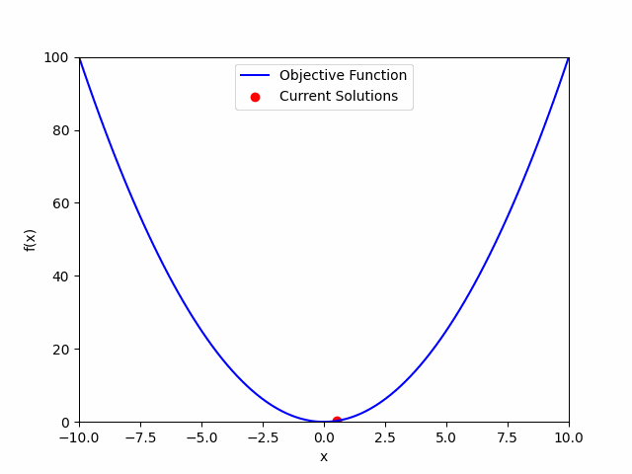

Exercise 4

Find the average convergence time for each function.

## Code

*# Exercise 4*

import numpy as np

def f1(*x*, *y*):

    return (*x* - 1) ** 2 + *y* ** 2

def f2(*x*, *y*):

    return (1 - *x*) ** 2 + 100 * (*y* - *x* ** 2) ** 2

def pso(*fitness_func*, *swarm_size*=50, *max_iter*=100, *c1*=2.0, *c2*=2.0, *w*=0.7):

    search_min = -5

    search_max = 5

    num_dims = 2

    swarm_pos = np.random.uniform(search_min, search_max, (*swarm_size*, num_dims))

    swarm_vel = np.zeros((*swarm_size*, num_dims))

    swarm_best_pos = np.copy(swarm_pos)

    swarm_best_fitness = np.full((*swarm_size*,), np.inf)

    global_best_pos = np.zeros((num_dims,))

    global_best_fitness = np.inf

    convergence_time = 0

    for i in range(*max_iter*):

        fitness = *fitness_func*(swarm_pos[:, 0], swarm_pos[:, 1])

        better_fitness_mask = fitness < swarm_best_fitness

        swarm_best_pos[better_fitness_mask] = swarm_pos[better_fitness_mask]

        swarm_best_fitness[better_fitness_mask] = fitness[better_fitness_mask]

        best_particle_idx = np.argmin(swarm_best_fitness)

        if swarm_best_fitness[best_particle_idx] < global_best_fitness:

            global_best_pos = np.copy(swarm_best_pos[best_particle_idx])

            global_best_fitness = swarm_best_fitness[best_particle_idx]

            convergence_time = i

        r1 = np.random.uniform(*size*=(*swarm_size*, num_dims))

        r2 = np.random.uniform(*size*=(*swarm_size*, num_dims))

        swarm_vel = *w* * swarm_vel + *c1* * r1 * (swarm_best_pos - swarm_pos) + *c2* * r2 * (global_best_pos - swarm_pos)

        swarm_pos += swarm_vel

        swarm_pos = np.clip(swarm_pos, search_min, search_max)

    return global_best_pos, global_best_fitness, convergence_time

*# Run PSO multiple times to get the average convergence time*

num_runs = 10

f1_convergence_times = []

f2_convergence_times = []

for i in range(num_runs):

    _, _, convergence_time = pso(f1)

    f1_convergence_times.append(convergence_time)

    _, _, convergence_time = pso(f2)

    f2_convergence_times.append(convergence_time)

*# Print the average convergence time for each function*

print("Average convergence time for f1:", np.mean(f1_convergence_times))

print("Average convergence time for f2:", np.mean(f2_convergence_times))

## Output

